JAVA
ASSIGMENT 1
Name – Veer Parmar
PRN – 26070122508
Div – B ( B3)

Title - Develop an application based on Java environment setup, JDK/JRE/JVM, variables, methods and constructors. and demonstrate the implementation of the concepts through suitable examples.

Problem Statement - Develop an application based on Java environment setup, JDK/JRE/JVM, variables, methods and constructors. and demonstrate the implementation of the concepts through suitable examples.
Learning Objectives - Understand the theoretical concepts, implement them in Java programs, analyze outputs, and apply the concepts to solve practical programming problems.

Theory -
Java environment setup, JDK/JRE/JVM, variables, methods and constructors. forms an important component of Java programming. Students should understand the underlying concepts, architecture, advantages, use cases, and implementation methodology. The exercise should focus on understanding the design principles, coding practices, execution flow, and practical applications of these concepts in software development. Detailed study should include syntax, APIs, execution process, and real-world applications.
Code –
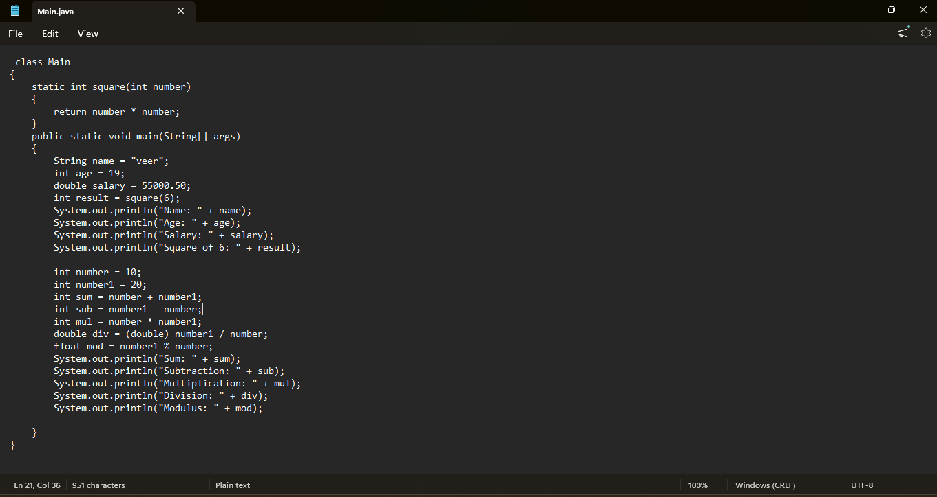

Output -
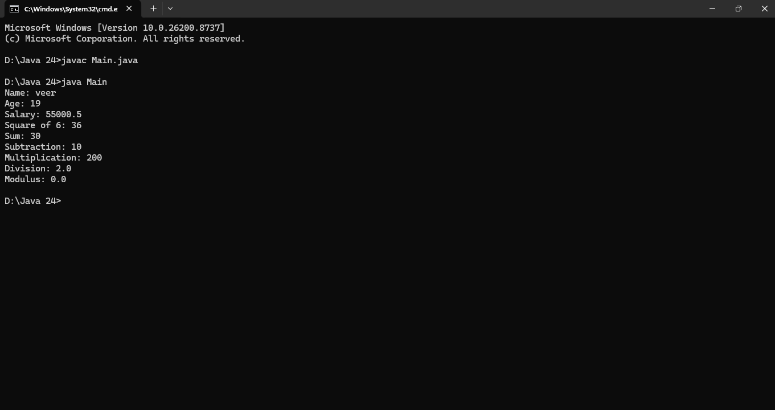

Exercise
- Explain the main concept used in Java environment setup, variables and methods.
Answer –
Setup: Setting up the Java environment is basically telling your computer where to find the Java tools (JDK). We set environment variables like PATH so the OS can compile (javac) and run (java) our code using the JVM.
Variables: A variable is just a named spot in memory used to store data. Because Java is strictly typed, we have to declare the data type (like int or String) beforehand so the compiler knows what kind of data it holds.
Methods: Methods are named blocks of code that do specific tasks. The main idea is modularity—breaking a big program into smaller pieces. We pass inputs into them, they do the work, and can return a result.
- What are the advantages of using Java variables and methods?
Answer –
Variables: They make code readable by using names instead of raw memory addresses. Also, Java's strict type safety prevents common errors, like trying to store text into a math variable.
Methods: The biggest advantage is reusability (Don't Repeat Yourself). If I need to calculate tax multiple times, I just write the method once and call it. It also makes debugging easier because if there's an error, I only fix it in one place.

- How can this implementation be improved?
Answer –
Variables: Use descriptive names (accountBalance instead of a). Also, declare variables as locally as possible so they don't take up memory or get changed by accident.
Methods: They should follow the Single Responsibility Principle—a method should do exactly one thing. If a method calculates totals and prints receipts, split it into two. Also, keep the number of parameters low; if a method needs too many inputs, pass an object instead.

- What are the real-world applications?
Answer –
- Enterprise Software (CRM and ERP)
Big companies use Java to build management software (like Salesforce or SAP).

Application: Everything is modeled as an object. A Customer object holds variables like name, purchase history, and contact info. Methods like generateInvoice() or sendEmail() contain the business logic. Inheritance is used to create different types of users (e.g., an Admin class inheriting from a User class) so the company doesn't have to rewrite code for basic user features.
- Android Mobile Applications
The Android operating system uses Java as one of its primary languages.

Application: When you use an app, variables store your login status, profile picture URL, or current GPS coordinates. Methods are what make the app interactive. For example, an onButtonClick() method triggers the logic to submit a form, and a fetchLocation() method talks to the phone's hardware to get your map coordinates.
- Web Servers and Cloud Applications
Java is widely used to build the backend servers that handle millions of requests for websites.

Application: When you log into a website, a Java method receives your username and password, checks them against a database, and creates a "Session" object. Variables inside that object keep track of what items you have in your cart as you browse different pages, ensuring your data doesn't get mixed up with another user's data.
Conclusion –
Understading JDK/JRE/JVM , variables , methods and their implementation through suitable examples

